3. Use 10-fold CV to estimate the MSPE for ridge, LASSO-min, and LASSO-1SE. That

is,

(a) Set the seed to 2928893 before running the sample.int() function.

(b) Create 10 folds

(c) Run the three analyses on each training set

i. Find the best versions of each for that training set

ii. Use those best versions to compute the prediction error on the validation set

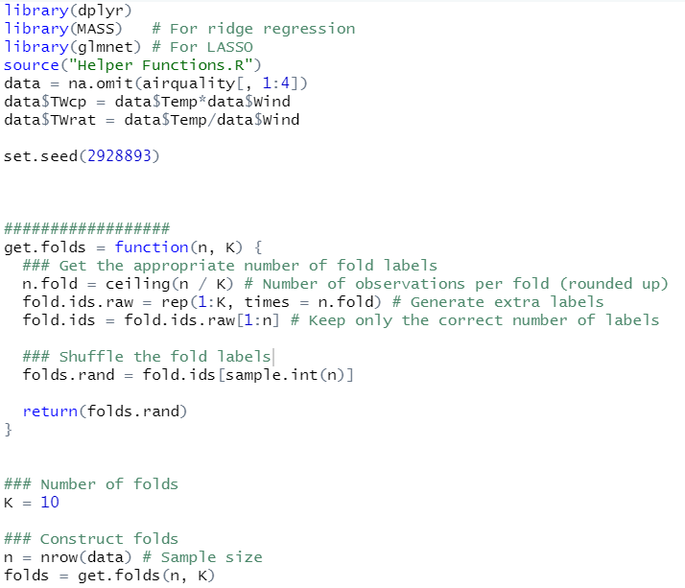

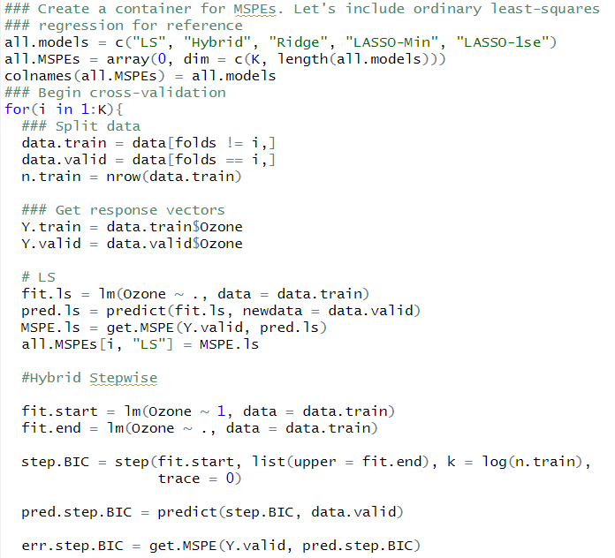

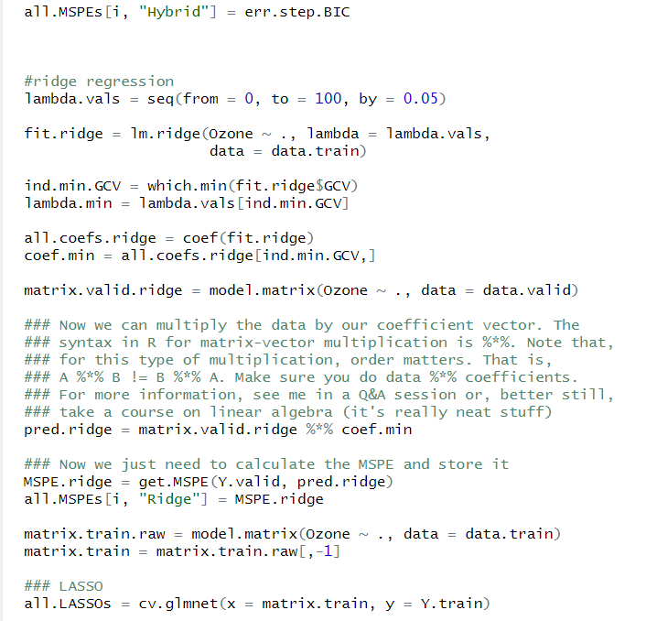

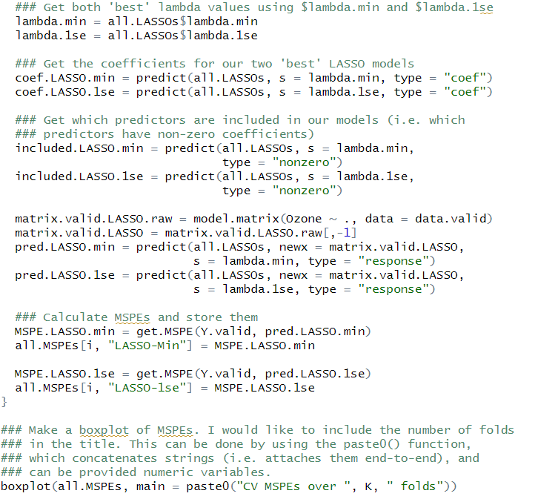

(d) **Report the separate MSPEs from each fold,** *MSPEv, v* = 1*, . . . ,* 10 **and**

**the MSPE for the full data.**

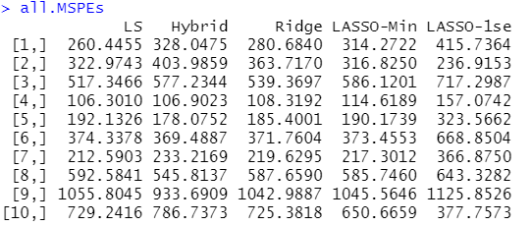

(e) **Make a boxplot of the 10 CV error estimates showing the boxes for**

**least squares, hybrid stepwise, ridge, and LASSO. Comment on any**

**apparent differences in how the methods seem to perform.**

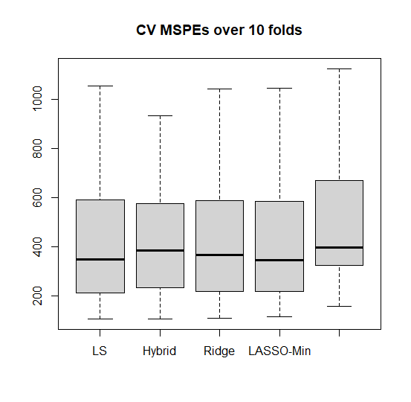

(f) **Repeat this using relative MSPE.**

